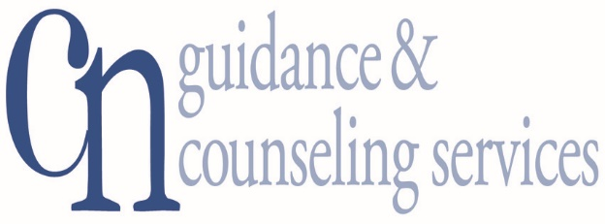
Addiction Recovery Treatment Services
Now Providing Ancillary Withdrawal Services @ our Hicksville Location

- Assessments
- Individual Counseling
- Group Counseling
- Free Family Education and Support Groups
- Vocational Counseling
- Psychiatric Services
- Suboxone Inductions
- Medication Assisted Treatment

For confidential inquiries and appointments
Contact Martine Ritter, 516.822.6111

Most Insurances Accepted Including Medicaid and Medicare, Sliding Scale

CN Guidance & Counseling Services
950 South Oyster Bay Road ● Hicksville, New York 11801
Phone: 516.822.6111 www.CNGuidance.org

