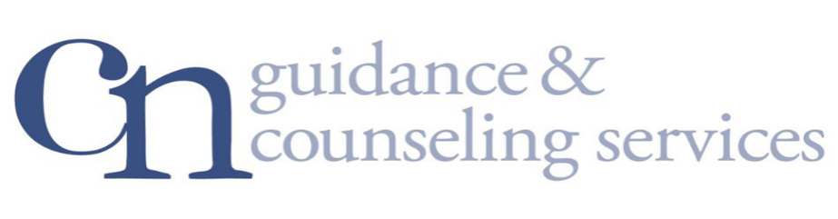
INTEGRATED COUNSELING &
RECOVERY SERVICES

FAMILY/SIGNIFICANT OTHER
EDUCATION SERIES & SUPPORT GROUP

FREE & OPEN TO THE COMMUNITY
THURSDAYS 6:30 PM – 7:30 PM

- Understanding Addiction
- Family Impact
- Exploring Defenses
- Letting Go of Control
- Enabling
- Developing Emotional Clarity
- Caring Detachment

950 South oyster bay road hicksville, ny 11801
For more information contact: Roseann Falcone, LMHC, CASAC
@ 516-822-6111, ext #1445 rfalcone@centralnassau.org

